COVID-19 safety PROCeDURES
Updated 2021



Contents
COVID-19 PROTOCOLS STATEMENT 3
RESPONSIBILITIES 4
COVID-19 SYMPTOMS AND TREATMENT 5
COMMUNICATION PROCEDURES 6
COVID-19 INFECTION CONTROL & PREVENTION MEASURES 7
COVID-19 CASES IN THE WORKPLACE PROTOCOLS 11
PPE 13
EVALUATION AND UPDATES 15
APPENDIX A: PRACTICE PROPER HAND WASHING TECHNIQUES POSTER 16
APPENDIX B: COVID-19 WORKPLACE POSTER 17
APPENDIX C: INDIVIDUAL WORKER HEALTH SCREENING QUESTIONNAIRE 18
APPENDIX D: COVID-19 PREVENTION INSIDE AND OUTSIDE THE WORKPLACE 19

COVID-19 PROTOCOLS STATEMENT

[THE COMPANY] recognizes its responsibility to minimize the potential exposure of its workers to any communicable disease, including COVID-19, whilst ensuring the continuity of our business operations. The workplace and job sites will be monitored on an as-needed basis for chemical, biological and physical agents to ensure we are maintaining a safe work environment.
During times of outbreak, epidemic, and pandemic of any communicable disease, additional precautions will be implemented as per these procedures.
In an effort to contain and minimize the spread of the disease and to ensure your safety and that of your fellow workers; EFFECTIVE IMMEDIATLEY, [THE COMPANY] is implementing these procedures, since the health and well-being of our entire community — including each of you — is our priority. The following policies and procedures apply to all employees, contractors, sub-contractors, and visitors of [THE COMPANY] at all our worksites.
Definitions
Communicable Diseases: Communicable diseases are those defined by the Health Protection and Promotion Act, Ontario Regulation 558/91; Communicable diseases are illnesses caused by infectious pathogens including viruses, bacteria, fungi, protozoa, prions, and parasites.
Outbreak: A sudden increase in occurrences of a disease in a particular time and place.
Epidemic: An outbreak of disease that spreads quickly and affects many individuals at the same time.
Pandemic: An outbreak of a disease that occurs over a wide geographic area and affects an exceptionally high proportion of the population.
Coronavirus: Coronaviruses (CoV) are a large family of viruses that are common and are typically associated with illnesses similar to the common cold. A novel coronavirus (nCoV) is a new strain that has not been previously identified in humans. And is therefore difficult to treat in infected individuals.
COVID-19: An infectious disease caused by a newly discovered coronavirus. Most people infected with the COVID-19 virus will experience mild to moderate respiratory illness and recover without requiring special treatment. Older people, and those with underlying medical problems like cardiovascular disease, diabetes, chronic respiratory disease, and cancer are more likely to develop serious illness. The COVID-19 virus spreads primarily through droplets of saliva or discharge from the nose when an infected person coughs or sneezes, so it’s important that you also practice respiratory etiquette (for example, by coughing into a flexed elbow).

RESPONSIBILITIES

Management Responsibilities:
Under Section 25(2) (h), of the Occupational Health and Safety Act, [THE COMPANY], as the employer must: take every precaution reasonable in the circumstances for the protection of a worker.
The Management of [THE COMPANY] will:
- stay abreast of guidance from federal, provincial, local, and/or territorial health agencies, and incorporate those recommendations and into our workplace. (https://www.ontario.ca/page/construction-site-health-and-safety-during-covid-19)
- implement this policy in its entirety, by ensuring that Supervisors are adequately trained and equipped.
- provide the necessary hygienic supplies to supervisors and employees
- effectively and expediently communicate company procedures to be implemented, during periods of outbreak.
Supervisor Responsibilities
It is the responsibility of supervisors to:
- ensure that they are adequately trained and acquainted with this policy to ensure full implementation and compliance.
- ensure that their subordinates are aware of, and properly trained on these procedures.
- reduce face-to-face meetings to a minimum and hold site meetings in open spaces or outside;
- post signage to inform and update workers of any new developments
- post signage identifying where hand-washing stations are located;
- send anyone with symptoms home and require them to maintain 14 days of isolation.
- designate a location to serve as the isolation area until potentially sick or potentially infectious people can be removed from the worksite.
- track and maintain a comprehensive list of workers (and co-workers) on site and update it daily; as contact tracing may become necessary
- provide public health unit information on where employees worked as well as the contact information of any other employee who may have been exposed, if requested.
- Expediently implement these procedures as per Management instructions
Employee Responsibilities
- Employees are expected to adhere to, and work in compliance with this policy and the procedures herein.
- Under Section 28(1)(d) of the Act, employees have an obligation to report to his employer the existence any hazard they are aware of, and as such, employees are required to report any violations of these procedures to your supervisor.
- Any employee found to be deliberately in contravention of these procedures, will be putting themselves and others, at risk, and shall be subject to disciplinary action, up to and including dismissal.
The Right to Refuse
Under Section 25, of The Act, every worker has to the “Right to Refuse” unsafe work. During times of pandemic, employees have the freedom to exercise this right, if they feel unsafe at work. Employees exercising this right shall adhere to the procedures outlined in [THE COMPANY] Occupational Health and Safety Procedures, and the guidelines established by the Occupational Health and Safety Act.
Worker Enquiries
Any concerns or questions regarding these procedures should be directed to any or all of the following:
- Your supervisor or foreman
- The Joint Health and Safety Committee
- Your Health and Safety Representative
- Your local public health agency or telehealth

COVID-19 SYMPTOMS AND TREATMENT
COVID-19 Symptoms and Treatment: The following are excerpts from the Ministry of Health concerning Covid-19:
Symptoms range from mild – like the flu and other common respiratory infections – to severe, and can include:
- fever
- cough
- difficulty breathing
- loss of sense of taste/smell
- nausea, diarrhea, and/or vomiting
Complications can include serious conditions, like pneumonia or kidney failure, and in some cases, death. There are no specific treatments for coronaviruses, and there is no vaccine that protects against coronaviruses. Most people with common human coronavirus illnesses will recover on their own.
You should:
- drink plenty of fluids
- get rest and sleep as much as possible
- try a humidifier or a hot shower to help with a sore throat or cough The Ministry of Labour advises that persons experiencing symptoms of COVID-19 contact Telehealth Ontario at 1-866-797-0000 or your local public health unit.
Do not call 911 unless it is an emergency.
How to Protect Yourself
Take these everyday steps to reduce exposure to COVID-19 and protect your health:
- wash your hands often for a minimum of 20 seconds with soap and warm water or alcohol-based hand sanitizer
- sneeze and cough into your sleeve
- avoid touching your eyes, nose or mouth
- avoid contact with people who are sick
- stay home if you are sick

COMMUNICATION PROCEDURES

In order to maintain the safety of the worksite, all employees are responsible to immediately report all potential and actual COVID- 19 hazards which you are aware of, that pose a potential threat to health or safety.
When implementing measures for control and containment of COVID-19, consideration must also be given to non-occupational risk factors at home, in community settings, and individual workers’ risk factors as well;
- older age;
- presence of chronic medical conditions
- immunocompromising conditions;
- pregnancy
In instances where the hazard cannot be eliminated from the jobsite, appropriate engineering, administrative, and control at the worker-level measures, shall be implemented.
Public Health Guidelines
Employees are strongly advised to follow local Public Health Agency Guidelines & Communiqué, for control and testing protocols as directed by said agency, during times of pandemic.
The Ministry advises that persons experiencing any symptoms related to COVID-19 contact Telehealth Ontario at 1-866-797-0000 or your local public health unit.
Communication Methods
While the COVID-19 pandemic is active, the following methods of communication shall be employed to keep workers informed:
- Posters and notices will be posted throughout the jobsite
- Safety Meetings will be held with employees
- COVID-19 procedures shall be reviewed with all employees
- COVID-19 notices will be posted up on notice boards and be made available to all employees
- Electronic means shall be used to communicate as much as possible, in lieu of face to face contact (company website, phone calls, texts etc.)
- Updates from Public Health Officials shall be communicated to workers as much as possible.

COVID-19 INFECTION CONTROL & PREVENTION MEASURES

All employees are expected to cooperate in taking steps to reduce the transmission of COVID-19 in the workplace. These measures are intended to contain the spread of COVID-19 by keeping sick or potentially sick people away from the jobsite, so that it will remain safer for those who must continue to report to work.
Visitors & Customers
All non-essential visitors shall refrain from visiting any [THE COMPANY] worksite.
Effective immediately, all unnecessary person-to-person contact is prohibited, this includes but is not limited to:
- Coffee trucks, Food trucks, Mobile Canteens, Hot Dog Vendors, etc.
* Employees are encouraged to plan accordingly
Any visitors or customers allowed on the worksite shall adhere to all social distancing protocols.
Deliveries
- Employees receiving packages are instructed to observe all Social Distancing protocols as outlined in these procedures. Allow non-urgent deliveries to sit for the recommended period before touching.
- Disinfect items that have been handled by others as much as possible. ALWAYS wash hands after handling these items.
Sick Employees
Many times, with the best of intentions, employees report to work even though they feel ill. During times of pandemic, it is critical that employees not report to work while they are experiencing respiratory symptoms such as fever, cough, shortness of breath, sore throat, runny or stuffy nose, body aches, headache, chills or fatigue, or any other such symptoms as indicated by the existing Government Agency.
During times when communicable diseases such as COVID-19 pose a threat to the health and well-being of employees as well as that of the entire community; employees who report to work ill will be sent home in accordance with these health guidelines.

Self-Assessment Tool
If you think you have symptoms of the virus or have been in close contact with someone who has it, visit ontario.ca and use the self-assessment tool to help determine how to seek further care.
https://covid-19.ontario.ca/self-assessment/#q0
Respiratory Etiquette
- COVID-19 can spread from person-to-person and is generally thought to spread by respiratory droplets when people are in close contact.
- All employees are strongly advised to practice respiratory etiquette;
  - Cover your face with tissues whenever when you cough or sneeze, and discard used tissues in the trash, and wash your hands immediately thereafter.
  - In the absence of tissues, best practice is to do so using the inside crook of your elbows.

Physical Distancing at the Worksite
In order to ensure that workers are keeping the recommended physical distance of two (2) meters from each other, whilst at work, the following measures shall be put in place:
- Re-scheduling Workers:
  - The number of workers on the job site at any given time shall be limited to ensure workers can keep the required 2 meters apart.
  - Trades schedules shall be staggered so that there is only ONE trade at any given time at the jobsite.
- Scheduling the use of man operated machinery: hoists, cranes, elevating work platforms etc.
- Assess accordingly each ride on hoist and elevator; keep a minimum distance of 2 meters at all times.
- Staggered Breaks and Lunches.

Work Hours & Scheduling
- Extended work hours may be implemented if necessary, to facilitate physical distancing at the jobsite.
- Staggered Shift Scheduling, with different start times to be implemented, as necessary.

Social Distancing
Social distancing is another term used to describe Physical Distancing; it means taking steps to limit the number of people you come into close contact with outside the workplace. This will help to limit the spread any contagion in the community.

Social distancing includes, but is not limited to:
- Spending time in settings where people can maintain a 2-metre (6 feet) distance from each other (e.g. site trailer, job site, indoors and outdoors etc.)
- Limit the amount of person to person contact you have (2-3 persons at the same time {1})
- Avoid common greeting methods (handshakes, kissing, cheek to cheek greetings etc.)
- Avoiding visits to long-term care homes, retirement homes, supportive housing, hospices and other congregate care settings unless the visit is absolutely essential
- Avoiding non-essential trips in the community
- Keeping the windows down in a vehicle if you have to go into the community for an essential trip via taxi or rideshare
- Holding virtual meetings whenever possible.
- Use telephone and video conferencing instead of face-to-face meetings as much as possible during times of outbreak
- Limiting or cancelling group gatherings, both professionally and socially.
Self-Isolation
A critical step in protecting workers, customers, visitors, and others at a worksite is prompt identification and isolation of sick and potentially infectious individuals as well.
Any employee exhibiting signs of COVID-19 infection should;
- Immediately inform your supervisor.
- Promptly separate (isolate) yourself from others, with the purpose of preventing the spread of COVID-19, including those within your home.
- Stay in the designated isolation area (as directed by your supervisor), until you can safely leave the jobsite.
Even if you do not have symptoms, it is recommended to self-isolate for the time frame indicated {2} if:
- You have travelled (or anyone in close contact to you has travelled) outside of the country within the time frame indicated (see footnote) by Health Canada.
- You live with, provided care for, or spent extensive time with any of the following:
- anyone who has tested positive for COVID-19
- anyone is suspected to have COVID-19
- anyone who has respiratory symptoms (fever, cough, or shortness of breath), or any other symptoms as indicated by public health agencies)
While in self-isolation, do not go to work, or any other public places. Consult your public health unit to find out when it is safe to leave your home.
If you are ill and are under self-isolation at home - you should be separated from others in your household to the greatest extent possible.
{1} Subject to change as per Health Official guidelines
{2} Time Frame is generally two (2) weeks – unless otherwise indicated by the Ministry of Health
Meetings
Essential meetings are to be held within all the parameters of Physical Distancing outlined previously in these procedures.
Social Events
All non-essential meetings, lunches and social events and functions will be cancelled when it is the recommendation of the public health agency to do so.
Working from Home (if applicable)
- While not all positions are conducive to this arrangement, those positions with primary job duties that can be effectively performed remotely will be given consideration.
- Office employees - talk to your supervisor, manager about the possibility of working from home where possible
Proper Hand Washing
Ensure that you are washing your hands frequently and properly {3}, during times of outbreak. Wash your hands frequently with warm, soapy water for at least 20 seconds.
Wash your hands:
- when they are visibly dirty
- and after:
  - sneezing, coughing, blowing your nose
  - using the washroom
  - handling garbage
  - handling raw foods
  - outdoor activities
- before and after:
  - preparing and eating food
  - touching a cut or open sore
  - touching eyes, nose or mouth
If hand washing is not immediately available – use alcohol-based hand sanitizer.
{3} See– Proper Hand Washing Technique Poster
Avoid Transference
To avoid transferring COVID-19, it is important for all individuals, (whether symptomatic or not) to adhere to these guidelines:
- Avoid using other workers’ work tools and equipment, when possible.
- Do not take breaks, and lunch breaks within close proximity of other workers
- Avoid using other workers’ phones, desks, offices, when possible.
- Avoid touching your face, eyes, nose and mouth – so as not to inadvertently ingest any infectious agent.
- Use disposable cutlery and cups to avoid using reusable dishes, whenever possible
- Use disinfectant spray and/or wipes wherever possible; Be especially mindful of transference from touching, door handles, refrigerator handles, toilets, taps, office equipment keyboards, keypads etc.
- Use hand sanitizer when hand washing is not an option
- Avoid sharing food and beverages with anyone.
Car Pooling
- IMMEDIATELY refrain from carpooling. Carpooling is no longer permitted for workers.
- Workers using company vehicles will not allow more than THREE (3) persons at any given time in the vehicle. Changes to this amount will be communicated to workers on an ongoing basis.

COVID-19 CASES IN THE WORKPLACE PROTOCOLS

The following safe work practices shall be incorporated by all employees as a matter of daily routine during the time of a COVID-19 pandemic. In the situation where there is a positive case of COVID-19 in the workplace, the following steps should be taken to ensure everyone’s safety and limit the risk of the disease to spread to more employees.
Reporting COVID-19 Cases in the Workplace
If someone in your work area is exhibiting signs and symptoms {4} of COVID-19, the following steps should be taken:
- Immediately distance yourself from the sick worker.
- Immediately self-isolate (be alone) and avoid close contact with any other worker or person.
- Contact your supervisor IMMEDIATLEY.
- Make note of the following:
  - Time of occurrence
  - Exact Place/Location at the jobsite
  - Any other potential workers that came in contact with the affected worker
Your supervisor will discuss next steps with you, towards self-isolation {5} previously outlined, time frame etc.
{4} As indicated by the Governing Health Agency
{5} See Self Isolation Guidelines

Identified COVID-19 Cases in the Workplace
- Supervisor shall designate a location away from workers/customers/visitors, with closable doors (if possible) to serve as the isolation area until potentially sick or potentially infectious people can be removed from the worksite.
- Ensure that all workers know and have access to the area.
- Restrict the number of personnel entering the isolation area.
- Immediately direct the sick employee to this area – instruct the employee to stay there, until removal from the worksite.
- Supervisor to trace contacts of infected worker using daily employee list.
- All employees in prolonged contact with the infected worker, meaning that they spent more than 15 minutes in the same enclosed area with the infected worker shall be instructed to self-isolate and shall not be allowed on the worksite for the time recommended by the governing health agency.
- Supervisors to follow all Public Health directives for the reporting and managing of identified positive cases in the workplace.
- ALL employees will cooperate fully with measures put in place.
- Worksite shall be sanitized thoroughly prior to any work recommencing, using methods prescribed by the Health Agency.
Contract Tracing
If an employee receives a positive COVID-19 test result, public health authorities will work diligently to trace their movements, identify anyone with whom they may have come into close contact and will notify those individuals directly.
[THE COMPANY] will support and comply with any requests of the public health officials and conduct a complementary investigation of their own. The company will work with the employee to make a list of each person with whom they have been within six feet of in the workplace at any point during the previous 14 days. This list may include others outside of the organization, such as suppliers, vendors, and visitors. The company will keep track of contact information for any people from outside of the company who enter the building.
The company will contact each individual from the list to let them know that they have been in contact with a person who is infected with COVID-19 and that they should consult with their physician or public health authority.
Sanitization
[THE COMPANY] has increased sanitization measures to ensure that high contact surfaces are frequently and thoroughly cleaned in order to reduce and eliminate the spread of workplace illnesses. Commonly touched surfaces are at greater risk for becoming contaminated with workplace illnesses, but many common cleaning products are effective against illnesses such as COVID-19.

Surface Cleaning Products
Cleaners
- Break down grease and remove organic material from the surface.
- Used separately before using disinfectants.

Disinfectants
- Have chemicals that kill most germs.
- Applied after the surfaces have been cleaned.

Disinfectant Wipes
- Have combined cleaners and disinfectants in one solution.
- May become dry due to fast drying properties. Should be discarded if they become dry.

Cleaning Procedures
- A cleaning record is to be established and signed off at the beginning of the day and the end of the day when the work area has been sanitized.
- If management has been informed that there has been an employee with a positive COVID-19 diagnosis, they will work with the employee to create a list of all areas that they physically worked in over the last 3 days. The areas in question will be immediately quarantined, ventilated if possible, and thoroughly cleaned.
- Proper PPE, such as masks and gloves, should be worn while handling cleaning supplies.
- All surfaces should be cleaned twice per day.
- In addition to routine cleaning, surfaces that have frequent contact with hands should be cleaned and disinfected twice per day and when visibly dirty.
  - Examples include doorknobs, elevator buttons, light switches, toilet handles, counters, hand rails, touch screen surfaces and keypads.
- After handling any cleaning products, dispose of gloves safely and wash your hands with warm water and soap for a minimum of 20 seconds.
- Inform management immediately when cleaning and sanitization supplies are running low to ensure that these items are properly stocked at all times.

PPE

Under section 28 of the Act, workers have a duty to use the PPE required by law, as well as by the employer. All employees are expected to comply with the PPE Policy as outlined in our company Occupational Health and Safety Program and Procedures, at all times.
Furthermore, workers are required to comply with any additional PPE requirements implemented during times of outbreak of any communicable diseases.
It is important to remember that PPE only provides protection. It reduces the risk, but does not eliminate the hazard. In addition to wearing proper PPE, it is imperative that all workers follow the preceding prescribed measures, to limit the spread of viral contagious agents, especially during times of outbreak.
Gloves
- Employees will wear the appropriate type of glove that affords them with the correct level of protection when there is any risk of coming into contact with raw sewage, food products, or other biological material or chemicals.
- Ensure that gloves fit comfortably but firmly to prevent bacteria from entering the glove from the wrist.
- Ensure that there are no holes or damage to the gloves. If gloves get damaged, remove them carefully and wash your hands for a minimum of 20 seconds immediately.
- When moving on to a new task, remove gloves carefully and wash your hands for a minimum of 20 seconds to prevent cross contamination.
- Do not touch your bare skin, face, or eyes while wearing gloves.
- Do not share used gloves with other employees.
- Do not reuse gloves.
- Throw used gloves into the receptacle provided. Do not throw used gloves on the ground or leave them at workstations.
- Inform management if glove supply is running low.
Masks
- Ensure that face mask fits comfortably but firmly to prevent bacteria from entering the mask from open points. The mask must cover the nose, mouth, and chin at all times.
- Ensure that there are no holes or damage to the mask. If the mask gets damaged, remove it carefully and wash your hands for a minimum of 20 seconds immediately.
- If you need to adjust your mask, avoid touching your face or eyes while doing so and ensure that you have washed your hands for a minimum of 20 seconds immediately before adjusting your mask.
- Do not touch the front of the face mask when trying to remove it as it may have been exposed to contaminants.
- Do not share used masks with other employees.
- Do not reuse masks
- Throw away used masks into the receptacles provided. Do not throw used masks on the ground or leave them at workstations.
- Inform management if face mask supply is running low.

EVALUATION AND UPDATES

The standards outlined in this procedure will be evaluated and updated in accordance with Ministry of Health guidelines.
All the necessary steps will be taken to ensure that all employees are working in compliance with these policies and that the appropriate steps are taken to ensure full implementation.
Updates will be communicated expediently to workers, as they become available to [THE COMPANY].
Employees are encouraged to stay abreast of developments and recommendations of the local Health Agency, as these will change continuously.
References:
Occupational Health and Safety Act, Workplace Safety and Insurance Act, Public Health Services Ottawa, Toronto Public Health Unit, Infrastructure Health and Safety Association (IHSA)

APPENDIX A: PRACTICE PROPER HAND WASHING TECHNIQUES POSTER

APPENDIX B: COVID-19 WORKPLACE POSTER
ATTENTION!!
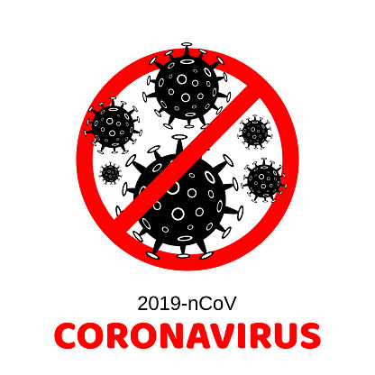
Are you experiencing any of the following symptoms?
✓ Cough?
✓ Fever?
✓ Shortness of Breath?
Have you (or anyone in close contact to you) travelled outside of Canada in the last 14 days?
Please SELF ISOLATE and contact your Health Care Provider or call Telehealth Ontario at 1-866-797-000

APPENDIX C: INDIVIDUAL WORKER HEALTH SCREENING QUESTIONNAIRE



COVID-19 Screening Questions
Have each employee answer the following questions before the beginning of their shift.
Name: _______________________________ Date: ____________________ Time: ______________
Do you have any of the following symptoms? Check each box if an employee indicates that they have that symptom:
- Fever
- Cough
- Difficulty Breathing, shortness of breath
- Sore Throat, Trouble Swallowing
- Runny Nose
- Loss of Sense of Taste and/or Smell
- Nausea, Diarrhea, and/or Vomiting
- Pink Eye (not related to reoccurring styes)
- Headache (not related to tension, chronic, migraines or other known conditions)
- Digestive Issues like Nausea/vomiting, Diarrhea, stomach pain (not related to IBS cramps or other known conditions)
- Muscle Aches (not related to injury , fibromyalgia, and not other known conditions)
- Extreme Tiredness (unusual fatigue, lack of energy, not related to depression insomnia, thyroid or other known conditions)

Have you been in close contact with someone who is sick or who has comfirmed that they have COVID-19 in the past 14 days?
- Yes
- No

Have you travelled outside of Canada in the past 14 days?
- Yes
- No

If the employee has answered YES to any of these questions, they must go home and self-isolate. They should call their health care provider or TeleHealth Ontario at 1-866-797-000 and find out if they need to get tested for COVID-19.

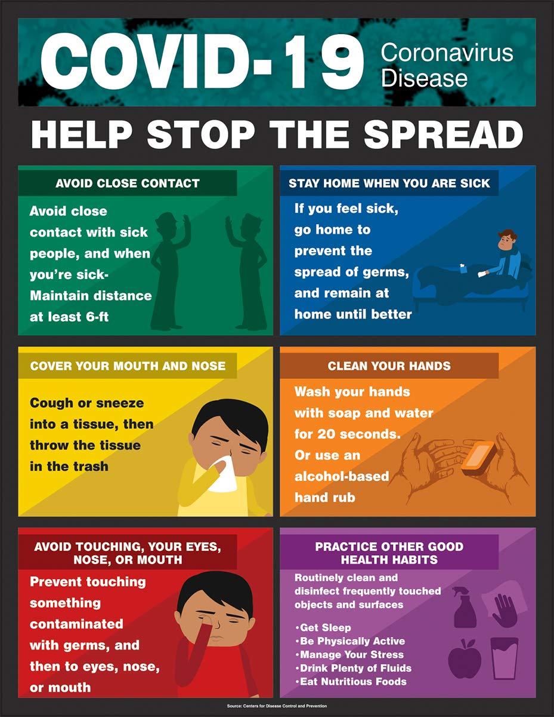
APPENDIX D: COVID-19 PREVENTION INSIDE AND OUTSIDE THE WORKPLACE

